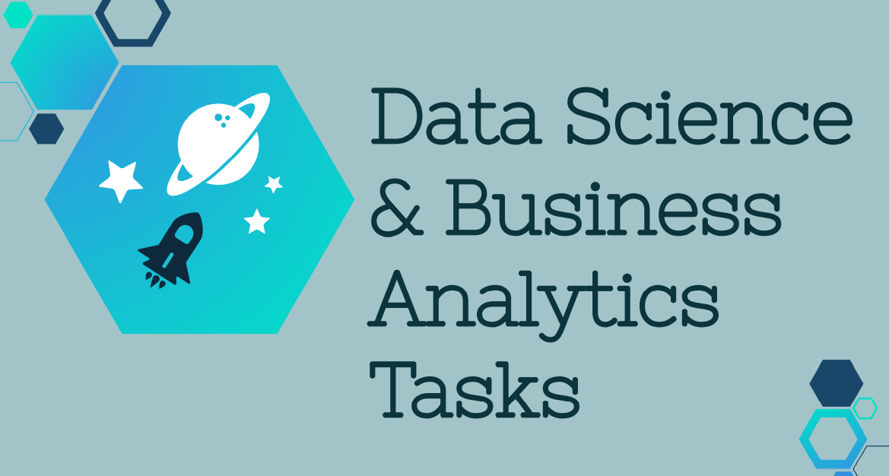

All tasks are completed by Ameya Harshad Chaudhari

Task 1: Prediction using Supervised ML

(Level - Beginner)

● Predict the percentage of an student based on the no. of study hours.

● This is a simple linear regression task as it involves just 2 variables.

● You can use R, Python, SAS Enterprise Miner or any other tool

● What will be predicted score if a student studies for 9.25 hrs/ day?